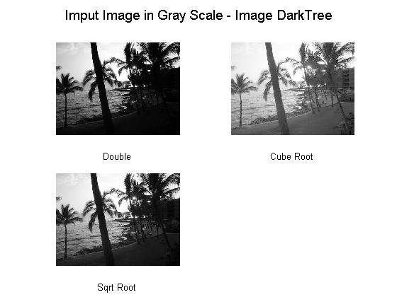
im= imread('DarkTree.JPG');
im2= im2double(im);
im3= rgb2gray(im2);
%figure, imshow(im3);

im4= im3.^(1./3);
im5= im3.^(2./3);

figure,
subplot(2, 2, 1),imshow(im3); xlabel('Double');
subplot(2, 2, 2),imshow(im4); xlabel('Cube Root');
subplot(2, 2, 3),imshow(im5); xlabel('Sqrt Root');

suptitle('Imput Image in Gray Scale - Image DarkTree');

imm= imread('DarkLog.JPG');
imm2= im2double(imm);
imm3= rgb2gray(imm2);
%figure, imshow(im3);

imm4= imm3.^(1./3);
imm5= imm3.^(2./3);

figure,
subplot(2, 2, 1),imshow(imm3); xlabel('Double');
subplot(2, 2, 2),imshow(imm4); xlabel('Cube Root');
subplot(2, 2, 3),imshow(imm5); xlabel('Sqrt Root');
suptitle('Imput Image in Gray Scale - Image DarkLog');
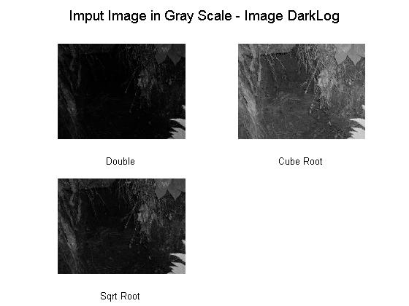
By converting the input image to im2double (Double), then applying the gray scale (rgb2gray), I came up with the above images: Double which is the original image, the Cube and the Sqrt root image. By comparing the image output it is noticeable that the cube root image is the more clear image due to that the matrix values are smaller than the other image matrixes.
for i=0:1:2,

if i == 0
x= im3;
end;

if i ~= 0
x= im3.^(i./3);
end;

figure;

temp = imadjust(x);
subplot(2, 2, 1),imshow(temp);
xlabel('No Gamma');
if i == 0
ylabel('Double Images');
end;
if i == 1
ylabel('Cube Root Images');
end;
if i == 2
ylabel('Sqrt Root Images');
end;

temp = imadjust(x,[],[], 0.5);
subplot(2, 2, 2),imshow(temp);xlabel('Gamma is 0.5');

temp = imadjust(x,[],[], 0.6);
subplot(2, 2, 3),imshow(temp);xlabel('Gamma is 0.6');

temp = imadjust(x,[],[], 0.7);
subplot(2, 2, 4),imshow(temp);xlabel('Gamma is 0.7');

suptitle('Adjusting image intensity (imadjust) - Image DarkTree');
end;

for i=0:1:2,

if i == 0
x= im3;
end;

if i ~= 0
x= im3.^(i./3);
end;

figure;

temp = imadjust(x);
subplot(2, 2, 1),imhist(temp);
xlabel('No Gamma');
if i == 0
ylabel('Double Images');
end;
if i == 1
ylabel('Cube Root Images');
end;
if i == 2
ylabel('Sqrt Root Images');
end;

temp = imadjust(x,[],[], 0.5);
subplot(2, 2, 2),imhist(temp);xlabel('Gamma is 0.5');

temp = imadjust(x,[],[], 0.6);
subplot(2, 2, 3),imhist(temp);xlabel('Gamma is 0.6');

temp = imadjust(x,[],[], 0.7);
subplot(2, 2, 4),imhist(temp);xlabel('Gamma is 0.7');
suptitle('Adjusting image intensity (imadjust) Graph - Image DarkTree');
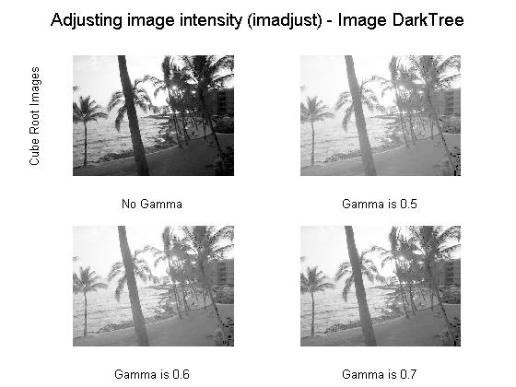
end;
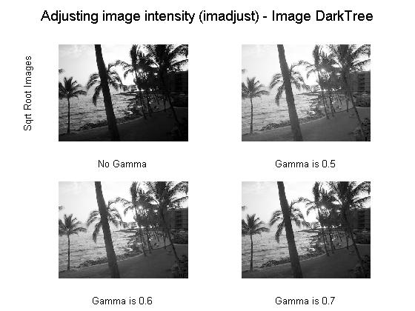
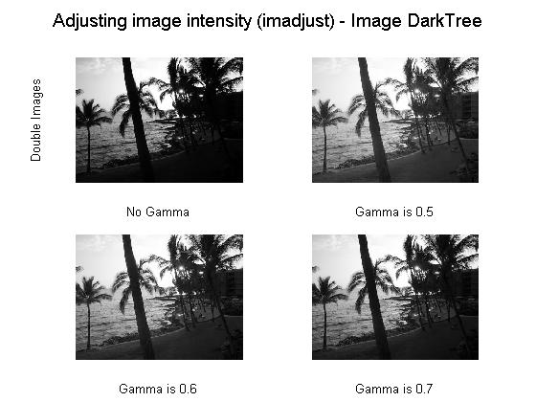

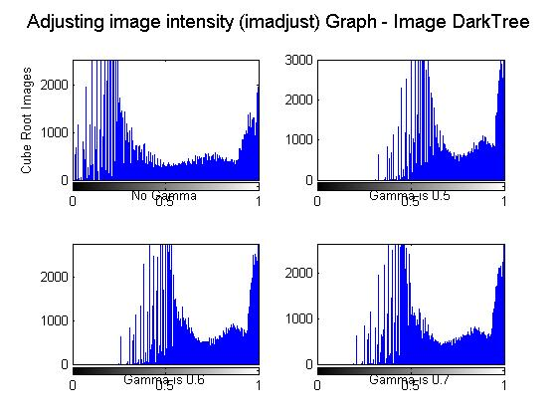
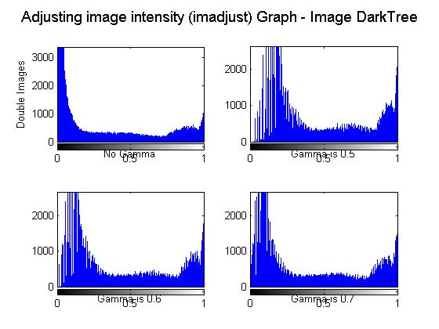

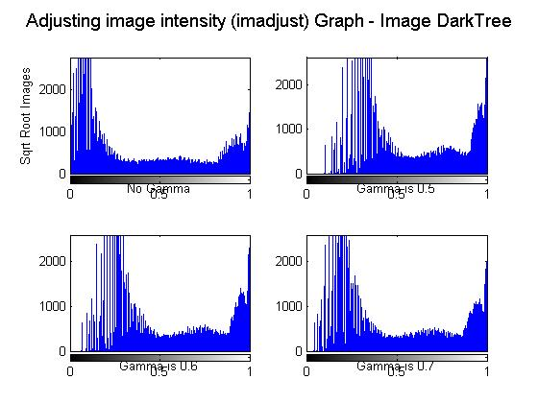

In this section I applied the “imadjust” function to both images, as described above, to the three different images obtained from above with different gammas to obtain a different and clearer light in the image. As a result, for what we can observe at gamma 0.7 in the Sqrt root image the dark side comes out to be more visible in both cases for both images. More details are explained below.

for i=0:1:2,

if i == 0
x= imm3;
end;

if i ~= 0
x= imm3.^(i./3);
end;

figure;

temp = imadjust(x);
subplot(2, 2, 1),imshow(temp);
xlabel('No Gamma');
if i == 0
ylabel('Double Images');
end;
if i == 1
ylabel('Cube Root Images');
end;
if i == 2
ylabel('Sqrt Root Images');
end;

temp = imadjust(x,[],[], 0.5);
subplot(2, 2, 2),imshow(temp);xlabel('Gamma is 0.5');

temp = imadjust(x,[],[], 0.6);
subplot(2, 2, 3),imshow(temp);xlabel('Gamma is 0.6');

temp = imadjust(x,[],[], 0.7);
subplot(2, 2, 4),imshow(temp);xlabel('Gamma is 0.7');

suptitle('Adjusting image intensity (imadjust) - Image DarkLog');
end;

for i=0:1:2,

if i == 0
x= imm3;
end;

if i ~= 0
x= imm3.^(i./3);
end;

figure;

temp = imadjust(x);
subplot(2, 2, 1),imhist(temp);
xlabel('No Gamma');
if i == 0
ylabel('Double Images');
end;
if i == 1
ylabel('Cube Root Images');
end;
if i == 2
ylabel('Sqrt Root Images');
end;

temp = imadjust(x,[],[], 0.5);
subplot(2, 2, 2),imhist(temp);xlabel('Gamma is 0.5');

temp = imadjust(x,[],[], 0.6);
subplot(2, 2, 3),imhist(temp);xlabel('Gamma is 0.6');

temp = imadjust(x,[],[], 0.7);
subplot(2, 2, 4),imhist(temp);xlabel('Gamma is 0.7');

suptitle('Adjusting image intensity (imadjust) Graph - Image DarkLog');
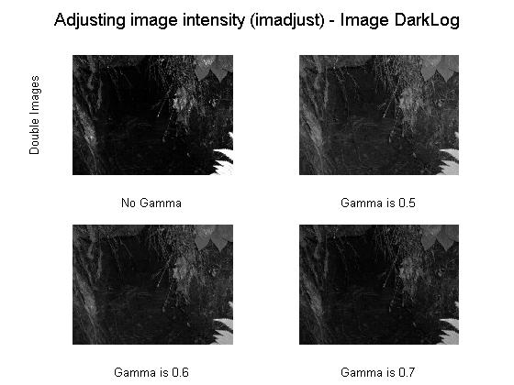
end;
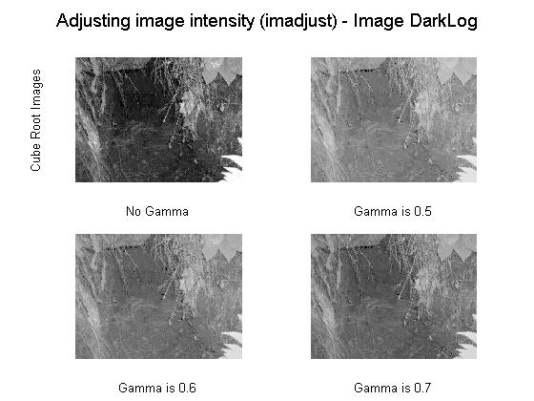

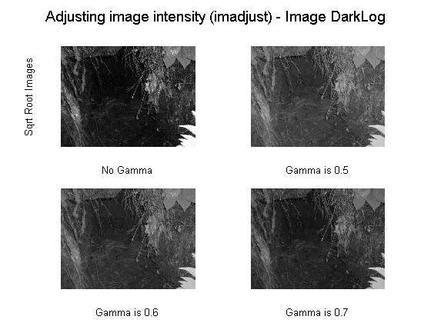
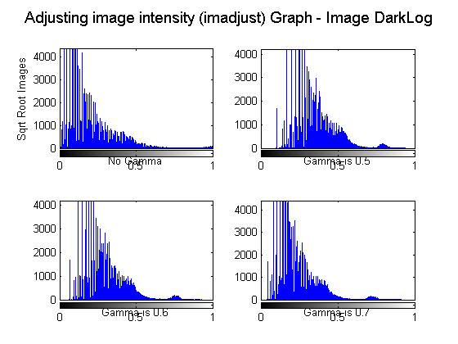
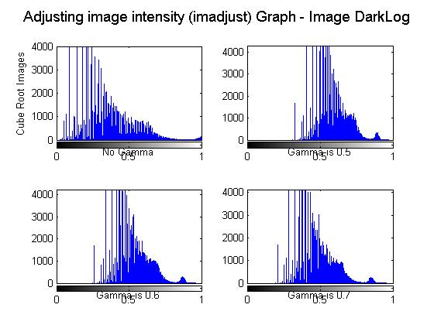
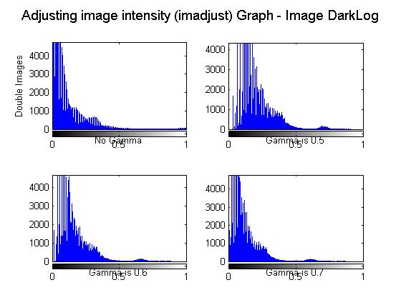
The scale graphs confirm what we saw above. At gamma 7 in the Sqrt root image the noise is being reduced and therefore the image light is more even and clear. Unlike in the first question, the sqrt image is now more visible than the Cube root image. The reason of this is because the matrix values of the sqrt image have been mapped in intensity image to new values in such that 1% of data is saturated at low and high intensities of the image increasing the contrast of the output image.
figure;
temp = histeq(im3);
subplot(2, 2, 1),imshow(temp);xlabel('Double');

temp = histeq(im3.^(1./3));
subplot(2, 2, 2),imshow(temp);xlabel('Cube Root');

temp = histeq(im3.^(2./3));
subplot(2, 2, 3),imshow(temp);xlabel('Sqrt Root');

suptitle('Equalized Histogram - Image DarkTree');
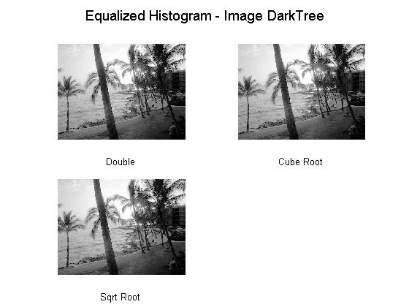
In this section I applied the “histeq” function to the three different images obtained from above. As we observe, all dark side of the images have been clear out almost at the same level of light and reasons why are explained below.

figure;
temp = histeq(im3);
subplot(2, 2, 1),imhist(temp);xlabel('Double');

temp = histeq(im3.^(1./3));
subplot(2, 2, 2),imhist(temp);xlabel('Cube Root');

temp = histeq(im3.^(2./3));
subplot(2, 2, 3),imhist(temp);xlabel('Sqrt Root');

suptitle('Equalized Histogram Graph - I mage DarkTree');

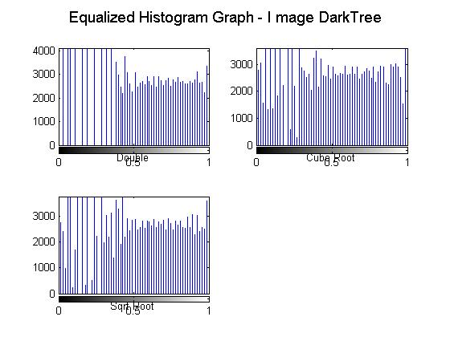

figure;
temp = histeq(imm3);
subplot(2, 2, 1),imshow(temp);xlabel('Double');

temp = histeq(imm3.^(1./3));
subplot(2, 2, 2),imshow(temp);xlabel('Cube Root');

temp = histeq(imm3.^(2./3));
subplot(2, 2, 3),imshow(temp);xlabel('Sqrt Root');

suptitle('Equalized Histogram - Image DarkLog');
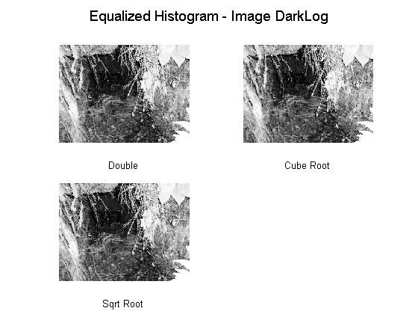

The “histeq” has enhanced the contrast of the images by transforming their matrix values in intensity images so that the histogram of the output image approximately matches a specified histogram, which is why all images look very similar.

figure;
temp = histeq(imm3);
subplot(2, 2, 1),imhist(temp);xlabel('Double');

temp = histeq(imm3.^(1./3));
subplot(2, 2, 2),imhist(temp);xlabel('Cube Root');

temp = histeq(imm3.^(2./3));
subplot(2, 2, 3),imhist(temp);xlabel('Sqrt Root');

suptitle('Equalized Histogram Graph - Image DarkLog');
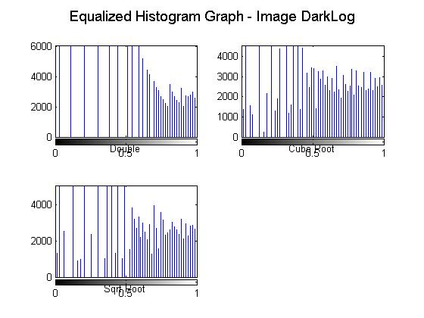
The graph of each image is very similar, which confirms the comment stated above while observing the image output produced by the function “histeq.”
figure;

temp = adapthisteq(im3);
subplot(2, 2, 1),imshow(temp);xlabel('Double');

temp = adapthisteq(im3.^(1./3));
subplot(2, 2, 2),imshow(temp);xlabel('Cube Root');

temp = adapthisteq(im3.^(2./3));
subplot(2, 2, 3),imshow(temp);xlabel('Sqrt Root');

suptitle('Adaptive Equalized Histogram - Image DarkTree');
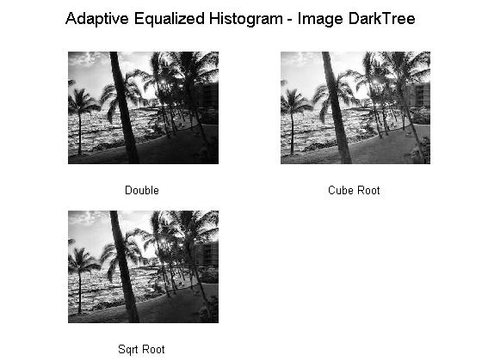
In this section I used the function “adapthisteq” and as we can observe the Cube Root image had a better response to such function since details are much clearer than the other images. Reasons why are being explained below.

figure;

temp = adapthisteq(im3);
subplot(2, 2, 1),imhist(temp);xlabel('Double');

temp = adapthisteq(im3.^(1./3));
subplot(2, 2, 2),imhist(temp);xlabel('Cube Root');

temp = adapthisteq(im3.^(2./3));
subplot(2, 2, 3),imhist(temp);xlabel('Sqrt Root');

suptitle('Adaptive Equalized Histogram Graph - Image DarkTree');
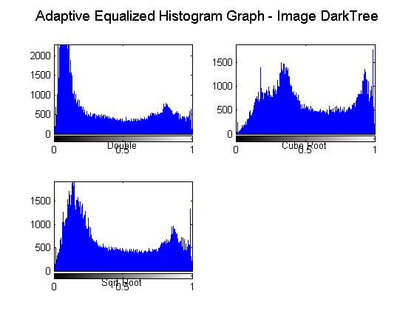
“ adapthisteq” enhanced the contrast of the intensity images by transforming their matrix values as the others function but using contrast-limited adaptive histogram equalization.

figure;

temp = adapthisteq(imm3);
subplot(2, 2, 1),imshow(temp);xlabel('Double');

temp = adapthisteq(imm3.^(1./3));
subplot(2, 2, 2),imshow(temp);xlabel('Cube Root');

temp = adapthisteq(imm3.^(2./3));
subplot(2, 2, 3),imshow(temp);xlabel('Sqrt Root');

suptitle('Adaptive Equalized Histogram - Image DarkLog');
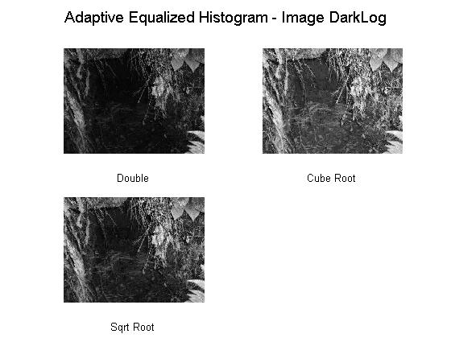
This function operated on small regions in the image, rather than the entire image. Each tile's contrast was enhanced, so that the histogram of the output region approximately matches the histogram specified by the'Distribution' parameter.

figure;

temp = adapthisteq(imm3);
subplot(2, 2, 1),imhist(temp);xlabel('Double');

temp = adapthisteq(imm3.^(1./3));
subplot(2, 2, 2),imhist(temp);xlabel('Cube Root');

temp = adapthisteq(imm3.^(2./3));
subplot(2, 2, 3),imhist(temp);xlabel('Sqrt Root');

suptitle('Adaptive Equalized Histogram Graph - Image DarkLog');
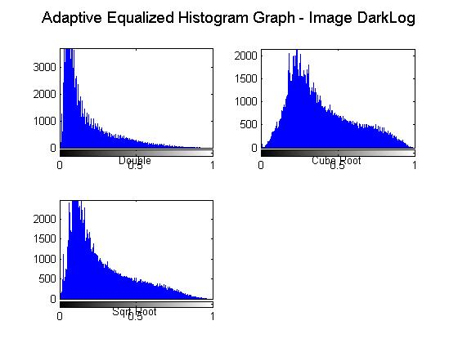
EXPERIMENTING
This is why Cube Root happens to be lighter that the others due the enhancement of the small values of its matrix. Doing this, the contrast, especially in homogeneous areas, can be limited to avoid amplifying any noise that might be present in the image.

for i=0.001:0.002:0.009

figure;

temp = adapthisteq(im3,'clipLimit',i,'Distribution','exponential');
subplot(2, 2, 1),imshow(temp);xlabel('Double');

temp = adapthisteq(im3.^(1./3),'clipLimit',i,'Distribution','exponential');
subplot(2, 2, 2),imshow(temp);xlabel('Cube Root');

temp = adapthisteq(im3.^(2./3),'clipLimit',i,'Distribution','exponential');
subplot(2, 2, 3),imshow(temp);xlabel('Sqrt Root');

suptitle('Adaptive Equalized Histogram - Image DarkTree');

end;

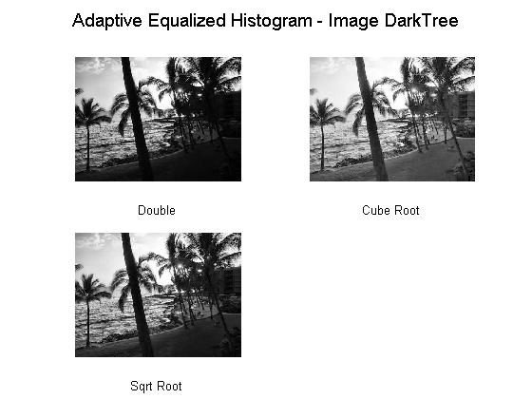
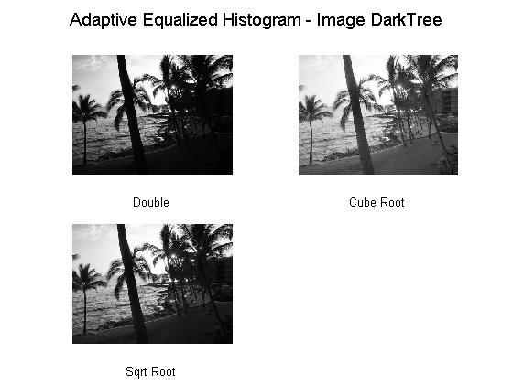
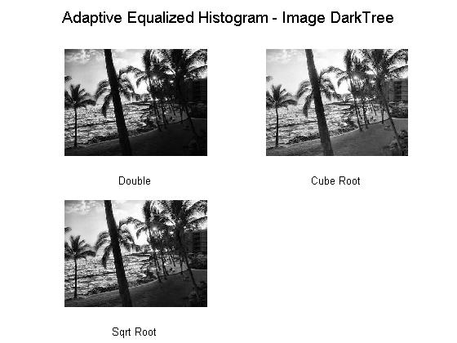

for i=0.01:0.02:0.09

figure;

temp = adapthisteq(im3,'clipLimit',i,'Distribution','exponential');
subplot(2, 2, 1),imshow(temp);xlabel('Double');

temp = adapthisteq(im3.^(1./3),'clipLimit',i,'Distribution','exponential');
subplot(2, 2, 2),imshow(temp);xlabel('Cube Root');

temp = adapthisteq(im3.^(2./3),'clipLimit',i,'Distribution','exponential');
subplot(2, 2, 3),imshow(temp);xlabel('Sqrt Root');

suptitle('Adaptive Equalized Histogram Graph - Image DarkTree');

end;
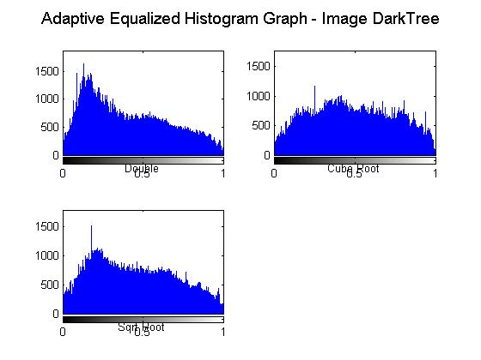
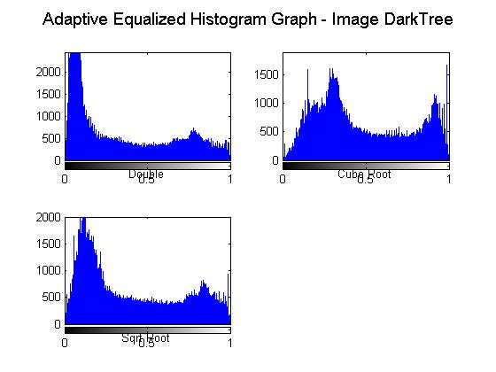

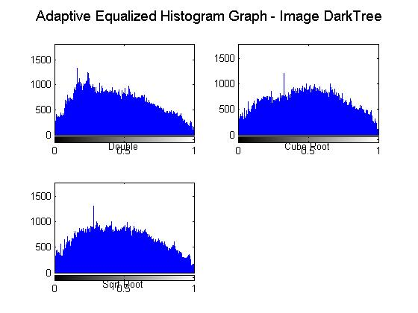

for i=0.001:0.002:0.009

figure;

temp = adapthisteq(imm3,'clipLimit',i,'Distribution','exponential');
subplot(2, 2, 1),imshow(temp);xlabel('Double');

temp = adapthisteq(imm3.^(1./3),'clipLimit',i,'Distribution','exponential');
subplot(2, 2, 2),imshow(temp);xlabel('Cube Root');

temp = adapthisteq(im3.^(2./3),'clipLimit',i,'Distribution','exponential');
subplot(2, 2, 3),imshow(temp);xlabel('Sqrt Root');

suptitle('Adaptive Equalized Histogram - Image DarkLog');

end;

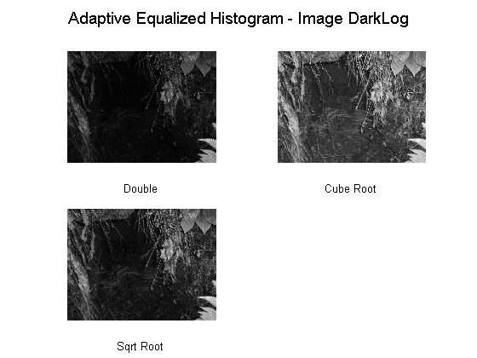
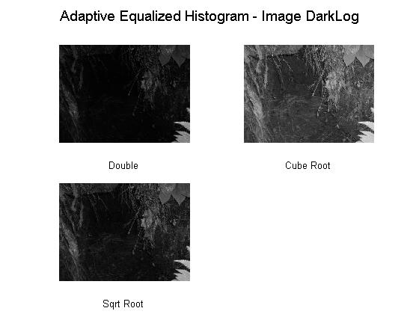

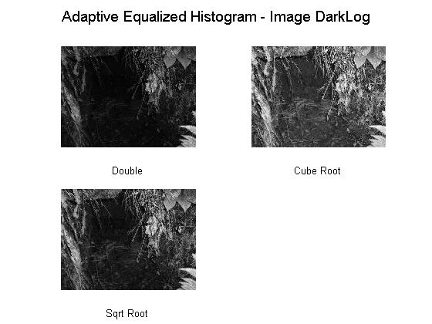

for i=0.01:0.02:0.09

figure;

temp = adapthisteq(imm3,'clipLimit',i,'Distribution','exponential');
subplot(2, 2, 1),imshow(temp);xlabel('Double');

temp = adapthisteq(imm3.^(1./3),'clipLimit',i,'Distribution','exponential');
subplot(2, 2, 2),imshow(temp);xlabel('Cube Root');

temp = adapthisteq(imm3.^(2./3),'clipLimit',i,'Distribution','exponential');
subplot(2, 2, 3),imshow(temp);xlabel('Sqrt Root');

suptitle('Adaptive Equalized Histogram Graph - Image DarkLog');

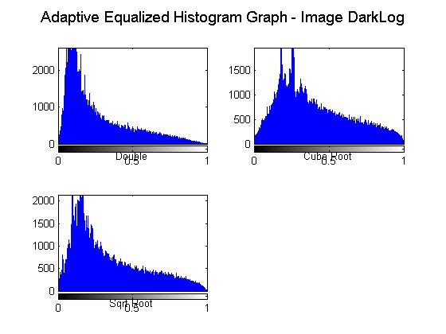
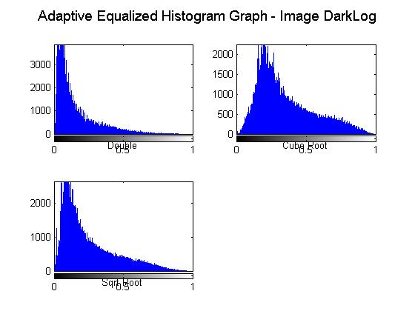
end;
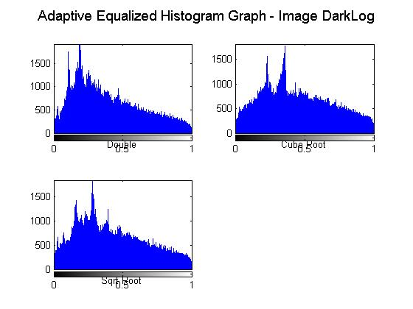
Note: In the experimenting part, the demonstration in Matlab were done by building a for loop that changes the 'ClipLimit' from 0.001 to 0.009 giving as an output the images shown in the actual job. As a result, these Images happen to have most of their dark regions more visible than the others. In the actual job the following images were compared at points 0.001, 0.003 and 0.009 and as the graph confirms at 0.003 is when a better image is display or output using the function adapthisteq.
SUMMARY

The main purpose of this job was to make the dark regions of the assigned images more visible with the following functions; Cube Root, Squared operator, imadjust, histogram equalization, and Adaptive histogram Equalization. By an observation point of view the Cube Root makes more visible dark regions of an image in comparison with the Square operator. Nevertheless, this is not a better choice since functions mentioned after these two such imadjust and Adaptive histogram Equalization prove to make visible most of the dark regions. The best and more clear image was displayed in the experimenting side with the “adapthisteq” function. This function as mention before operates on small regions in the image, called tiles, rather than the entire image. The contrast, especially in homogeneous areas, was limited to avoiding the amplification of any noise that might be present in the image.

On the other side, if the “ClipLimit” parameter was to miss in the function, the result obtained in the experimenting section would not have been possible since the scalar range 0 and 1 would not have had a limit specified to maintain a contrast enhancement.

